COIT20265 Networks and Information Security Project

Isolation Forest Autoencoder and Hybrid Model Development
Normal-only training, implementation verification and validation-threshold calibration for network anomaly detection

Student | Syed Rubaiyat Karim
Student ID | 12302352
Project group | PG3
Term | HT2 2026
Document status | Final technical artefact
Prepared | October 2026

Individual contribution statement
Normal-only training, implementation verification and validation-threshold calibration for network anomaly detection

Executive Summary
This artefact documents the implemented Isolation Forest, Dense Autoencoder and equal-weight Hybrid IF+AE used in the PG3 anomaly-detection prototype. The three notebooks use the same processed 41-feature UNSW-NB15 contract. Isolation Forest and the Autoencoder are fitted only on normal training records; the Hybrid does not retrain either component and instead combines their saved anomaly scores after validation-based percentile normalisation.
The implementation evidence is taken directly from the supplied Google Colab notebooks. The final Isolation Forest uses 300 trees, max_samples=0.8, all 41 features and random seed 42. The Autoencoder uses a 41-32-16-8-16-32-41 architecture with 4,049 trainable parameters, ReLU hidden layers, a linear reconstruction layer, Adam optimisation and mean-squared reconstruction loss. The Hybrid converts component scores to empirical validation percentiles and applies fixed 0.50/0.50 weighting.
All three implementations use normal validation scores to define 0.5%, 1% and 3% alert-budget thresholds. Test labels are used only after the model and threshold are fixed. At the 1% source-domain operating point, Isolation Forest, Autoencoder and Hybrid achieve F1-scores of 0.745, 0.755 and 0.753 respectively. These values are retained here only as implementation-verification evidence; detailed cross-domain transfer, recalibration and wider threshold sweeps are documented in the separate testing artefact.
The main technical contribution is therefore the reproducible implementation chain: validated input arrays, normal-only fitting, explicit score direction, validation-only threshold calibration, persistent model/configuration files, record-level evidence and a consistent handoff to the later testing and dashboard workstreams.
Table of content:
Executive Summary 2
1 Introduction 3
1.1 Purpose 3
1.2 Contribution boundary 3
1.3 Handoffs within the group project 4
2 Technical Requirements 4
3 Literature Review 5
3.1 Unsupervised network anomaly detection 5
3.2 Isolation Forest 5
3.3 Autoencoder anomaly detection 5
3.4 Hybrid score fusion 5
3.5 Thresholds and evaluation 5
4 Model Architecture and Data Flow 6
5 Isolation Forest 6
5.1 Algorithm 6
5.2 Implemented Configuration and Notebook Evidence 7
6 Dense Autoencoder 8
6.1 Architecture 8
6.2 Training Controls and Observed Learning Behaviour 9
7 Equal Weight Hybrid IF and AE 12
7.1 Why normalisation was required 12
7.2 Implemented Fusion, Verification and Output Contract 14
8 Threshold Selection and Sensitivity 14
8.1 Validation false-positive budget 14
8.2 Notebook-Verified Source-Domain Operating Points 14
9 Handoff to the Separate Testing Artefact 15
10 Evaluation Metrics and Interpretation 15
11 Reproducibility and Software Provenance 16
11.1 Exact Notebook and Output Provenance 16
11.2 Implementation Verification Matrix 16
12 Critical Evaluation 17
12.1 Strengths 17
12.2 Limitations 17
12.3 Recommended next steps 17
13 Ethical and Professional Considerations 18
14 Conclusion 18
References 18

1 Introduction

1.1 Purpose
The artefact explains what the three models calculate, how they were implemented, why their parameters were selected, how thresholds converted continuous scores into binary decisions, and what their results reveal about deployment beyond the training domain. The objective is not to present a single best model, but to provide traceable evidence for model choice and failure analysis.

1.2 Contribution boundary
Table 1. Scope of the three-model technical contribution
In scope | Out of scope
Isolation Forest final configuration, normal-only fitting, anomaly scoring and export | Development of LOF, One-Class SVM and Deep SVDD
Dense Autoencoder architecture, training controls, reconstruction scoring and export | UNSW source-data preparation
50/50 Hybrid percentile normalisation, score fusion and implementation verification | GNS3 topology and Zeek capture
Validation thresholds at 0.5%, 1% and 3% plus source-domain implementation evidence | Ownership of the complete six-model testing artefact
Notebook provenance, saved artefacts and handoff to separate testing/dashboard artefacts | Production deployment claims

1.3 Handoffs within the group project
The models consumed the 41-column UNSW arrays and saved feature order prepared in the benchmark artefact. The completed estimators, score functions and original thresholds were then supplied to the common testing pipeline. Labannya Barua led the complete three-stage comparison across six models, while the present artefact retains the implementation evidence and model-specific interpretation for Isolation Forest, Autoencoder and Hybrid. NF-CSE preparation is documented in the companion individual artefact.

2 Technical Requirements
Table 2. Model-development requirements
ID | Requirement | Verification evidence
MR1 | Normal-only fitting | No attack observation is supplied to model.fit or Autoencoder reconstruction training.
MR2 | Comparable anomaly direction | Higher scores must always represent stronger anomaly evidence.
MR3 | Independent validation threshold | The threshold is calculated from normal validation scores, not test labels.
MR4 | Reproducible training | Seeds, architecture and selected hyperparameters are recorded.
MR5 | Notebook-grounded implementation evidence | Final configuration, code path, score logic and persistent outputs are verified from the supplied notebooks.
MR6 | Scale-safe hybrid fusion | Component scores are normalised before equal weighting.
MR7 | Multiple evaluation measures | Precision, recall, F1, FPR, ROC-AUC, PR-AUC and confusion counts are reported.
MR8 | Model-development threshold evidence | 0.5%, 1% and 3% validation budgets are implemented in the model notebooks; wider sweeps belong to the testing artefact.
MR9 | Testing handoff | Saved models, thresholds and score conventions are passed unchanged to the separate cross-domain testing workflow.

3 Literature Review

3.1 Unsupervised network anomaly detection
Unsupervised anomaly detection seeks observations that differ from an estimated normal structure without requiring representative labels for every attack. Chandola, Banerjee and Kumar (2009) describe anomaly detection as the identification of patterns that do not conform to expected behaviour. In network security, the attraction of normal-only learning is its potential to flag behaviour that is absent from a signature set; its weakness is that legitimate changes can also appear anomalous (Ahmed, Mahmood and Hu, 2016).

3.2 Isolation Forest
Isolation Forest isolates observations through recursive random partitions rather than estimating a full density. Liu, Ting and Zhou (2008) show that anomalous points tend to require shorter paths because they are fewer and have attribute values that are easier to separate. The method is computationally suitable for large numeric datasets and offers a useful contrast to a neural reconstruction model.

3.3 Autoencoder anomaly detection
An Autoencoder learns a compressed representation by reconstructing its input. When trained only on normal traffic, poor reconstruction can be used as evidence that a record lies outside learned normal patterns. Sakurada and Yairi (2014) demonstrate Autoencoder-based anomaly detection, while Mirsky et al. (2018) apply ensembles of Autoencoders to online network intrusion detection. Reconstruction error remains sensitive to preprocessing, architecture, capacity and domain shift; a powerful model can reconstruct some attacks well, while a shifted normal record can produce a high error.

3.4 Hybrid score fusion
Tree isolation and neural reconstruction capture different properties. Combining them can broaden anomaly evidence, but their raw scores are not commensurate. Goldstein and Uchida (2016) emphasise that unsupervised detectors can behave differently across data characteristics. The project therefore placed each component score on a percentile scale before equal-weight fusion. Equal weighting was retained as the original configuration because it provides a transparent baseline and avoids claiming an optimised mixture without a separate weight-selection study.

3.5 Thresholds and evaluation
A continuous anomaly score does not define an alert until a threshold is selected. A budget of 1% means that the threshold is set near the 99th percentile of normal validation scores; it does not guarantee a 1% FPR on a different test set. ROC-AUC measures ranking across thresholds, whereas PR-AUC focuses on the precision-recall relationship and is especially informative under imbalance (Saito and Rehmsmeier, 2015). Binary operating metrics and ranking metrics must therefore be interpreted together.

4 Model Architecture and Data Flow
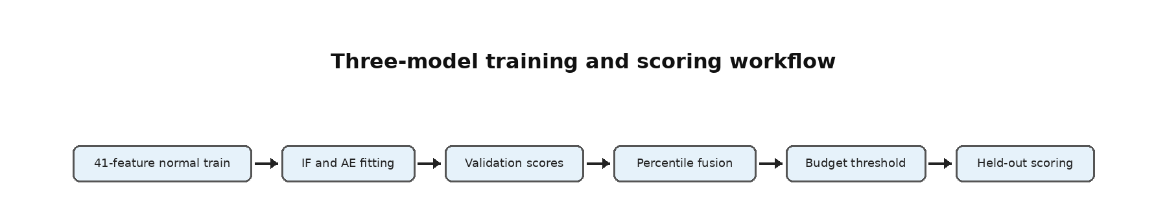
Figure 1. Separation of model fitting, score calibration and held-out evaluation
Table 3. Dataset contracts used by the three models
Data object | Shape or content | Permitted model use
train_normal.npz | 41,065 x 41 normal records | Fit Isolation Forest and train Autoencoder
val_normal.npz | 10,266 x 41 normal records | Candidate comparison and threshold calculation
test_full.npz | 82,332 x 41; 37,000 normal and 45,332 attack | Held-out source-domain implementation verification only

5 Isolation Forest

5.1 Algorithm
For a sample x, an isolation tree repeatedly chooses a feature and a split between the observed minimum and maximum. The path length h(x) is the number of partitions required to isolate the sample. With a subsample of size n, the normalising constant is based on the expected path length of an unsuccessful binary search tree.
c(n) = 2H(n − 1) − 2(n − 1) / n (1)
Equation 1. Isolation Forest path-length normalisation
s(x,n) = 2^[−E(h(x)) / c(n)] (2)
Equation 2. Canonical Isolation Forest anomaly score
The scikit-learn score_samples output was negated so that the project used one consistent direction: a larger value indicated stronger anomaly evidence.
S_IF(x) = −score_samples(x) (3)
Equation 3. Score direction used in the implementation

5.2 Implemented Configuration and Notebook Evidence

The supplied Isolation Forest notebook contains one completed project configuration rather than a documented multi-candidate search. The estimator is created with n_estimators=300, max_samples=0.8, max_features=1.0, contamination='auto', random_state=42 and n_jobs=-1, then fitted on all 41,065 normal training rows. The contamination setting is not used as the final alert rule; operational thresholds are calculated separately from normal validation scores.
Before fitting, the notebook verifies a common 41-feature input across training, validation and test arrays and checks the normal training matrix for NaN and infinity values. The recorded training range is -3.3884 to 7.9812 with mean 0.0841 and standard deviation 0.5489. After fitting, score_samples is negated so every exported model follows the same project convention: larger score means more anomalous.
Table 4. Implemented Isolation Forest configuration
Parameter | Selected value | Technical purpose
n_estimators | 300 | Average isolation behaviour across a larger ensemble
max_samples | 0.8 | Train each tree on 80% of normal training records
max_features | 1.0 | Allow the complete 41-feature representation
contamination | auto | Do not use training contamination to define the final project threshold
random_state | 42 | Reproduce tree construction and sampling
n_jobs | -1 | Use available processing cores

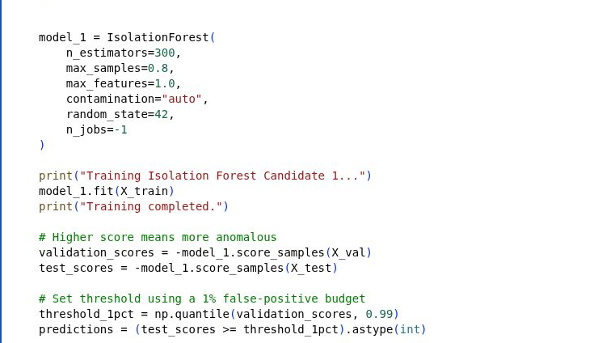
Code screenshot 1. Isolation Forest fitting, anomaly scoring and 1% validation threshold in the supplied Colab notebook.

Evidence item | Notebook-observed value
Training rows / features | 41,065 / 41
Validation rows / features | 10,266 / 41
Held-out test | 82,332 records: 37,000 normal + 45,332 attack
Training score mean | 0.400879
Validation score mean | 0.401017
Test score mean | 0.500772
1% validation threshold | 0.546054
1% test FPR | 4.82% (48.19 false alerts per 1,000 normal records)
Saved model | models/isolation_forest_candidate1.joblib
Saved configuration | config/isolation_forest_candidate1.json
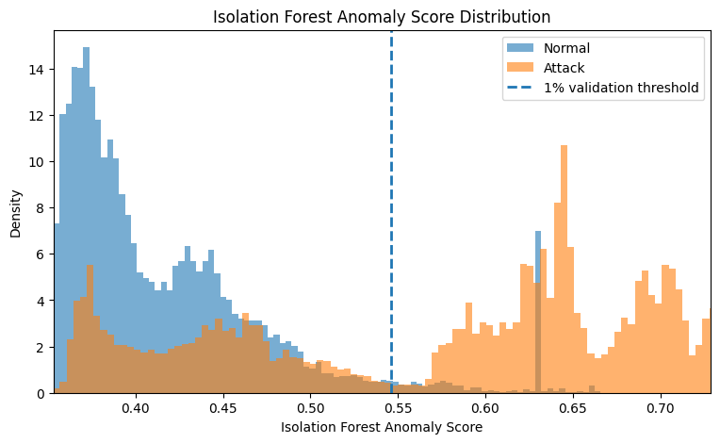
Figure 2. Isolation Forest normal-versus-attack anomaly-score distribution exported by the supplied notebook.

6 Dense Autoencoder

6.1 Architecture
The Autoencoder accepted the 41-feature input, compressed it through 32 and 16 units to an eight-unit bottleneck, and reconstructed the input through a symmetric decoder. ReLU activations introduced non-linearity in the hidden layers. A linear output retained the ability to reconstruct scaled continuous values without constraining them to a probability range.
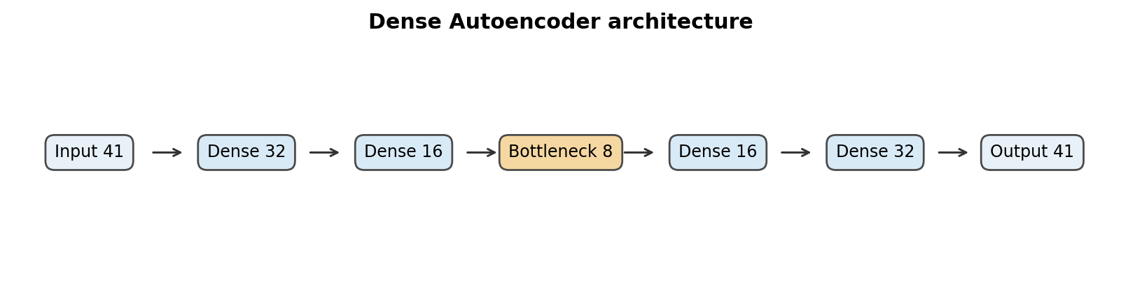
Figure 3. Symmetric encoder-decoder structure
S_AE(xᵢ) = (1/d) Σⱼ₌₁ᵈ (xᵢⱼ − x̂ᵢⱼ)² (4)
Equation 4. Mean squared reconstruction error used as the anomaly score

6.2 Training Controls and Observed Learning Behaviour

The supplied Autoencoder notebook implements one complete 41-32-16-8-16-32-41 network. The model contains 4,049 trainable parameters. Hidden layers use ReLU and the output layer is linear so reconstructed scaled features are not forced into a probability range. Adam starts at a learning rate of 0.001 and optimises mean-squared reconstruction error.
Training uses 41,065 normal rows with the 10,266 normal validation rows supplied as reconstruction targets. Batch size is 256 and the maximum is 100 epochs. EarlyStopping monitors validation loss with patience 10 and restore_best_weights=True; ReduceLROnPlateau uses factor 0.5, patience 5 and minimum learning rate 1e-6. In the recorded run early stopping did not terminate training early: epoch 100 remained the best validation-loss epoch. The learning rate was reduced at epoch 94 and again at the end of epoch 100.
The final mean reconstruction error was closely matched between training and normal validation data (approximately 0.005426 and 0.005425), while the mixed held-out test set had a higher mean error of approximately 0.04885. This difference is consistent with attack records producing larger reconstruction error on average, but the operational decision still depends on the separately calibrated threshold.
Table 5. Implemented Dense Autoencoder configuration
Parameter | Selected value | Purpose
Input and output | 41 units | Match the fixed model-ready feature order
Hidden structure | 32-16-8-16-32 | Learn a compact symmetric representation
Hidden activation | ReLU | Introduce non-linear feature interactions
Output activation | Linear | Reconstruct continuous scaled variables
Loss | Mean squared error | Penalise reconstruction difference
Optimizer | Adam | Adaptive gradient optimisation
Learning rate | 0.001 | Initial optimisation step size
Batch size | 256 | Balance memory and gradient stability
Maximum epochs | 100 | Upper limit; callbacks can stop earlier
Early stopping | Patience 10 | Restore the best validation-loss weights
Learning-rate reduction | Patience 5 | Reduce step size after a validation plateau
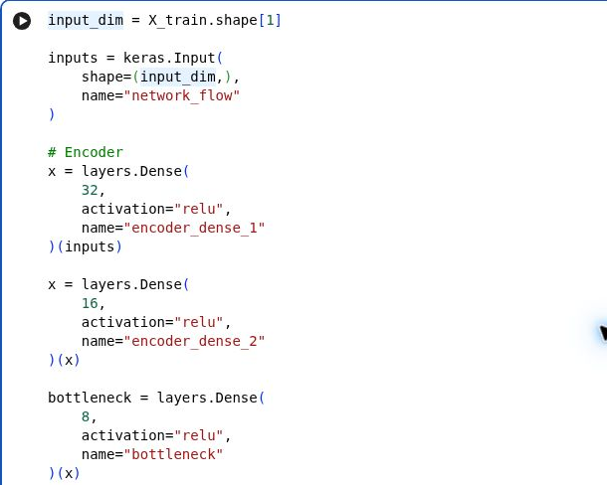
Code screenshot 2. Encoder layers and eight-unit bottleneck from the supplied Dense Autoencoder Colab notebook.

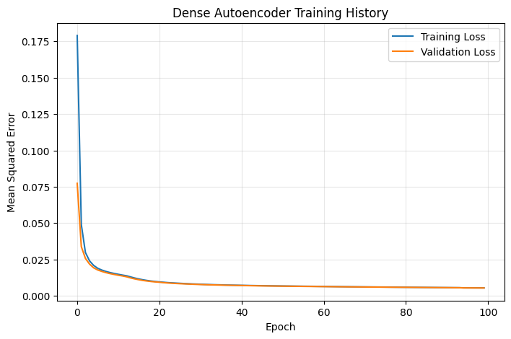
Figure 4. Dense Autoencoder training and validation loss from the supplied notebook.
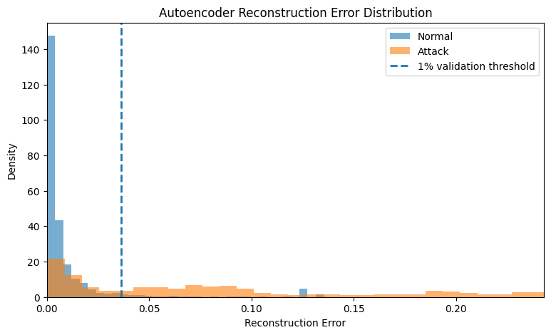
Figure 5. Autoencoder reconstruction-error distributions and 1% validation threshold from the supplied notebook.
Evidence item | Notebook-observed value
Architecture | 41-32-16-8-16-32-41
Trainable parameters | 4,049
Training strategy | Normal-to-normal reconstruction
Epochs completed | 100
Batch size | 256
Initial learning rate | 0.001
Train reconstruction error mean | 0.005426
Validation reconstruction error mean | 0.005425
Test reconstruction error mean | 0.048848
1% validation threshold | 0.036468
Saved model | models/autoencoder_candidate1.keras
Saved configuration | config/autoencoder_candidate1.json

7 Equal Weight Hybrid IF and AE

7.1 Why normalisation was required
Isolation Forest and Autoencoder scores have unrelated numerical scales. Adding them directly would allow whichever model produced larger raw values to dominate. Each score was therefore converted to its empirical percentile relative to that model's normal validation scores. This transformation preserved ordering while placing both components approximately on a zero-to-one scale.
Pₘ(x) = (1/(N+1)) Σᵢ₌₁ᴺ 1[Sₘ,ᵢ(val) ≤ Sₘ(x)] (5)
Equation 5. Empirical percentile normalisation against normal validation scores
S_Hybrid(x) = 0.50P_IF(x) + 0.50P_AE(x) (6)
Equation 6. Original equal-weight Hybrid score
The 50/50 weighting is transparent but not automatically optimal. It expresses equal contribution after normalisation and avoids selecting weights from the final test labels. A future weight study should use a separate development set and report whether improvements remain stable across domains.
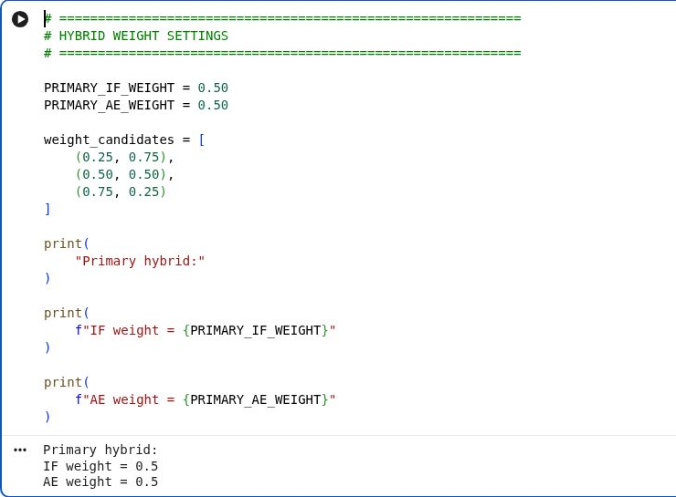
Code screenshot 3. The primary Hybrid weights set to 0.50 for each component in the supplied Colab notebook.
The notebook defines alternative weight tuples (0.25/0.75 and 0.75/0.25) as possible candidates, but the supplied execution evaluates and exports only the 0.50/0.50 primary Hybrid. The artefact therefore treats equal weighting as the implemented configuration and does not claim a completed weight-optimisation experiment.
Evidence item | Notebook-observed value
Component models | Saved Isolation Forest + saved Dense Autoencoder
Normalisation | Empirical percentile against each model's normal validation scores
Implemented fusion | 0.50 × IF percentile + 0.50 × AE percentile
Hybrid validation score range | 0.003799 to 0.999805
0.5% threshold | 0.990994
1% threshold | 0.980082
3% threshold | 0.938938
1% F1 / FPR | 0.7527 / 4.55%
Dashboard export | 82,332 rows × 23 columns
Saved configuration | config/hybrid_if_ae.json

7.2 Implemented Fusion, Verification and Output Contract
The Hybrid notebook does not retrain either component. It first checks that the normal validation array, held-out test array, saved Isolation Forest and saved Autoencoder are present, then loads the two frozen models. Isolation Forest scores are obtained from the negated score_samples output and Autoencoder scores from per-record mean squared reconstruction error. Each score stream is converted to an empirical percentile relative to its own normal validation distribution using a sorted reference array and np.searchsorted. The two percentile scores are then averaged with fixed 0.50/0.50 weights.
Notebook verification note: percentile_normalize sorts the normal-validation scores, uses np.searchsorted(..., side="right") and divides ranks by (N + 1), not N. This makes the transformation an empirical validation-reference rank rather than a continuously fitted scaler. Target scores above the largest reference value share the same top-normalized value, and equal reference scores receive the same rank; both effects can create ties or score saturation. The implemented 0.50/0.50 weights are fixed engineering choices, not evidence of a completed weight optimisation.

8 Threshold Selection and Sensitivity

8.1 Validation false-positive budget
For a budget b, the threshold is the (1-b) quantile of normal validation scores. A score at or above the threshold is labelled anomalous. The selected budget controls how permissive the detector is on the calibration sample; it does not guarantee the same measured FPR on held-out or external traffic.
τ_b = Q_(1−b)[S_normal(val)]; ŷ = 1[S(x) ≥ τ_b] (7)
Equation 7. Quantile threshold and binary decision rule
The 1% point was retained as the central model-development operating condition for consistent comparison. The three supplied model notebooks explicitly calibrate 0.5%, 1% and 3% budgets from normal validation scores. The later testing artefact extends sensitivity to 2%, 5% and 10%; those wider results are not repeated here.

8.2 Notebook-Verified Source-Domain Operating Points
Model | Budget | Threshold | Precision | Recall | F1 | Actual FPR
Isolation Forest | 0.5% | 0.567650 | 0.9494 | 0.6089 | 0.7419 | 3.97%
Isolation Forest | 1% | 0.546054 | 0.9401 | 0.6171 | 0.7451 | 4.82%
Isolation Forest | 3% | 0.496639 | 0.9050 | 0.6637 | 0.7658 | 8.53%
Dense Autoencoder | 0.5% | 0.045774 | 0.9472 | 0.5885 | 0.7260 | 4.02%
Dense Autoencoder | 1% | 0.036468 | 0.9364 | 0.6327 | 0.7552 | 5.27%
Dense Autoencoder | 3% | 0.023754 | 0.9126 | 0.6740 | 0.7753 | 7.91%
Hybrid IF+AE | 0.5% | 0.990994 | 0.9542 | 0.6128 | 0.7463 | 3.60%
Hybrid IF+AE | 1% | 0.980082 | 0.9440 | 0.6259 | 0.7527 | 4.55%
Hybrid IF+AE | 3% | 0.938938 | 0.9111 | 0.6792 | 0.7783 | 8.12%
These values are the operating points actually produced by the three supplied model notebooks. They show the expected development trade-off: relaxing the validation budget increases attack recall but also increases held-out false positives. They are implementation-verification results, not a substitute for the separate cross-domain testing analysis.

9 Handoff to the Separate Testing Artefact
This model-development artefact stops at the implemented models, source-domain scoring, validation thresholds and persistent outputs. The saved Isolation Forest, Autoencoder and Hybrid artefacts were then passed unchanged to the separate testing workflow. That report contains the full UNSW/NF-CSE frozen-threshold transfer, target-normal recalibration and wider 0.5%-10% sensitivity analysis.
Keeping those stages separate avoids duplicating result tables and preserves a clear ownership boundary: this document explains how the three models were built and verified; the testing artefact evaluates how the frozen models and thresholds behave after domain transfer.

10 Evaluation Metrics and Interpretation
Precision = TP / (TP + FP) (8)
Equation 8. Precision
Recall = TP / (TP + FN) (9)
Equation 9. Recall
F₁ = 2(Precision × Recall) / (Precision + Recall) (10)
Equation 10. F1-score
FPR = FP / (FP + TN) (11)
Equation 11. False-positive rate
Table 6. Complementary interpretation of the evaluation measures
Measure | Question answered | Important limitation
Precision | Of the generated alerts, how many are attacks? | Depends on the attack prevalence in the evaluated set
Recall | Of the attack records, how many were detected? | Can be maximised by flagging almost everything
F1-score | How balanced are precision and recall? | Does not include true negatives directly
FPR | What fraction of normal records became false alerts? | A small rate can still create many alerts at high volume
ROC-AUC | How well are classes ranked across thresholds? | May appear optimistic under strong imbalance
PR-AUC | How well is attack precision retained as recall changes? | Depends on class prevalence
Confusion matrix | What are the exact TN, FP, FN and TP counts? | Requires a specified operating threshold

11 Reproducibility and Software Provenance
Table 7. Source and reproducibility record
Component | Implementation evidence
Isolation Forest | scikit-learn IsolationForest; configuration and random seed recorded
Dense Autoencoder | TensorFlow/Keras Sequential model; layer widths, activations and callbacks recorded
Hybrid | Project score-fusion function using validation empirical percentiles and 0.50/0.50 weights
Thresholding | NumPy quantile calculation from normal validation or calibration scores
Metrics | scikit-learn classification and ranking metrics plus explicit confusion counts
Saved evidence | Candidate tables, budget tables, figures, notebooks, model files and exported result files

The implementation uses published algorithms and standard Python libraries, while the supplied notebooks contain the project-specific data loading, normal-only fitting, score orientation, threshold calibration, export and handoff logic. The exact model notebooks reviewed for this artefact are Isolation_forest_Model(6).ipynb, Dense_Autoencoder_Model(5).ipynb and Hybrid_IF_AE_Model(4).ipynb (the latest files supplied for independent document review). They run from the Google Drive project root /content/drive/MyDrive/intentmap-nids/intentmap-nids. Exact package versions should still be exported from the final Colab runtime and archived with the notebooks.

11.1 Exact Notebook and Output Provenance
Notebook / evidence | Implementation role | Persistent outputs
Isolation_forest_Model(6).ipynb | Input QA, IF fit, score direction, 0.5/1/3 thresholds, source evaluation | JOBLIB model, JSON config, budget CSV, 82,332×18 dashboard CSV, score PNG
Dense_Autoencoder_Model(5).ipynb | AE architecture, training callbacks, reconstruction scoring, thresholds, source evaluation | KERAS model, JSON config, budget CSV, 82,332×14 dashboard CSV, training-history PNG, score PNG
Hybrid_IF_AE_Model(4).ipynb | Load frozen IF/AE, percentile normalisation, 50/50 fusion, thresholds, comparison export | Hybrid JSON config, 82,332×23 dashboard evidence and model-comparison outputs
Shared project root | /content/drive/MyDrive/intentmap-nids/intentmap-nids | data/processed, models, config and reports folders

11.2 Implementation Verification Matrix
Verification check | Observed evidence
Feature contract | 41 columns for training, validation and test inputs
Training population | 41,065 normal records; no attack labels used for fitting
Validation population | 10,266 normal records used for threshold calibration
Held-out source test | 82,332 records = 37,000 normal + 45,332 attack
Input quality | Isolation Forest and AE notebooks report no NaN or infinite training values
Score direction | IF score_samples is negated; AE MSE and Hybrid percentile fusion increase with anomaly evidence
Output existence | Model/config/result files are explicitly saved and existence-checked in the notebooks
Dashboard row integrity | IF: 82,332×18; AE: 82,332×14; Hybrid: 82,332×23

12 Critical Evaluation

12.1 Strengths
The strongest part of the implementation is the common experimental contract. All three models consume the same 41-feature arrays, use normal-only fitting or frozen component models, orient scores in the same anomaly direction, calibrate thresholds from normal validation data and export persistent evidence. The supplied notebooks also preserve the exact final configurations and generated files, allowing the implementation to be checked without relying on copied report values.

12.2 Limitations
The supplied Isolation Forest and Autoencoder notebooks each contain one completed final configuration; therefore this artefact does not claim a verified multi-candidate model-selection experiment. The Hybrid notebook defines alternative weight tuples but executes and exports only the 0.50/0.50 fusion. The model-development notebooks calibrate 0.5%, 1% and 3% budgets only; wider budgets belong to the separate testing artefact. The Autoencoder ran the full 100 epochs because early stopping did not trigger, and exact Python/library versions are not pinned in the notebooks. The Hybrid notebook also overrides the Isolation Forest path in a later cell, which should be consolidated into one configuration variable for cleaner reproducibility.
Verification scope: the supplied Isolation_forest_Model(6).ipynb, Dense_Autoencoder_Model(5).ipynb and Hybrid_IF_AE_Model(4).ipynb were inspected for their implemented training, score and threshold logic. This is a code-level review of the saved notebooks, not a fresh end-to-end rerun with original arrays, saved model binaries and matched dependency versions. The IF code negates scikit-learn score_samples; AE uses per-record mean squared reconstruction error; both use normal-validation np.quantile thresholds for 0.5%, 1% and 3% budgets. Hybrid normalization uses a denominator of N+1, and final predictions use score >= threshold. The distinction between intended validation alert budget and measured held-out FPR must be maintained.

12.3 Recommended next steps
- Pin Python, scikit-learn, TensorFlow/Keras, NumPy and pandas versions in a requirements file and save the final Colab runtime information.
- Consolidate the Hybrid Isolation Forest path so one project-root definition is used throughout the notebook.
- If model-selection claims are required, run and save a pre-declared IF/AE candidate protocol rather than presenting unexecuted alternatives as completed experiments.
- Evaluate Hybrid weight alternatives only on a separate development/calibration set and retain the executed comparison evidence before changing the 0.50/0.50 baseline.
- Keep wider cross-domain threshold sweeps and recalibration results in the separate testing artefact so implementation and evaluation evidence remain traceable without duplication.

13 Ethical and Professional Considerations
An anomaly detector affects analyst workload and can influence decisions about users and devices. Reporting only recall would obscure the cost of false alerts. The artefact therefore gives FPR, false alerts per 1,000, ranking measures and known limitations. Models are not presented as autonomous evidence of malicious intent; alerts require contextual investigation.
Model files, feature mappings and training records should be versioned together. Reproducibility protects professional accountability because a result can be traced to the exact data contract, parameter set and threshold. Raw network identifiers should be minimised, access-controlled and excluded from public repository evidence unless their inclusion is necessary and authorised.

14 Conclusion
The three-model implementation provides a reproducible source-domain pipeline for Isolation Forest, Dense Autoencoder and the equal-weight Hybrid. The attached notebooks verify the complete chain from 41-feature inputs through normal-only fitting, anomaly-score construction, validation-only threshold calibration and persistent output generation.
Isolation Forest supplies a computationally simple tree-based score, the Autoencoder supplies reconstruction-error evidence from a 4,049-parameter neural model, and the Hybrid combines the two after percentile normalisation so raw score scale cannot dominate the fusion. The 0.5%, 1% and 3% notebook operating points make the detection-versus-false-alert trade-off explicit without using attack labels to choose the threshold.
The model artefact intentionally ends before cross-domain recalibration and wider deployment testing. Those experiments are documented separately, preserving a clean distinction between how the models were implemented and how their frozen outputs behave when transferred to another environment.

References
Ahmed, M., Mahmood, A.N. and Hu, J. (2016) 'A survey of network anomaly detection techniques', Journal of Network and Computer Applications, 60, pp. 19-31.
Chandola, V., Banerjee, A. and Kumar, V. (2009) 'Anomaly detection: A survey', ACM Computing Surveys, 41(3), pp. 1-58.
Goldstein, M. and Uchida, S. (2016) 'A comparative evaluation of unsupervised anomaly detection algorithms for multivariate data', PLOS ONE, 11(4), e0152173.
Khraisat, A., Gondal, I., Vamplew, P. and Kamruzzaman, J. (2019) 'Survey of intrusion detection systems: Techniques, datasets and challenges', Cybersecurity, 2, Article 20.
Moustafa, N. and Slay, J. (2015) 'UNSW-NB15: A comprehensive data set for network intrusion detection systems', Proceedings of the Military Communications and Information Systems Conference, pp. 1-6.
Ring, M., Wunderlich, S., Scheuring, D., Landes, D. and Hotho, A. (2019) 'A survey of network-based intrusion detection data sets', Computers and Security, 86, pp. 147-167.
Saito, T. and Rehmsmeier, M. (2015) 'The precision-recall plot is more informative than the ROC plot when evaluating binary classifiers on imbalanced datasets', PLOS ONE, 10(3), e0118432.
Sarhan, M., Layeghy, S., Moustafa, N. and Portmann, M. (2021) 'NetFlow datasets for machine learning-based network intrusion detection systems', Big Data Technologies and Applications, pp. 117-135.
Sarhan, M., Layeghy, S. and Portmann, M. (2022) 'Towards a standard feature set for network intrusion detection system datasets', Mobile Networks and Applications, 27, pp. 357-370.
Sommer, R. and Paxson, V. (2010) 'Outside the closed world: On using machine learning for network intrusion detection', Proceedings of the IEEE Symposium on Security and Privacy, pp. 305-316.
Liu, F.T., Ting, K.M. and Zhou, Z.H. (2008) 'Isolation Forest', Proceedings of the Eighth IEEE International Conference on Data Mining, pp. 413-422.
Mirsky, Y., Doitshman, T., Elovici, Y. and Shabtai, A. (2018) 'Kitsune: An ensemble of Autoencoders for online network intrusion detection', Proceedings of the Network and Distributed System Security Symposium.
Pedregosa, F. et al. (2011) 'Scikit-learn: Machine learning in Python', Journal of Machine Learning Research, 12, pp. 2825-2830.
Sakurada, M. and Yairi, T. (2014) 'Anomaly detection using Autoencoders with nonlinear dimensionality reduction', Proceedings of the MLSDA Workshop, pp. 4-11.

